**480 PSet 1: Linear Algebra Self-Assessment**

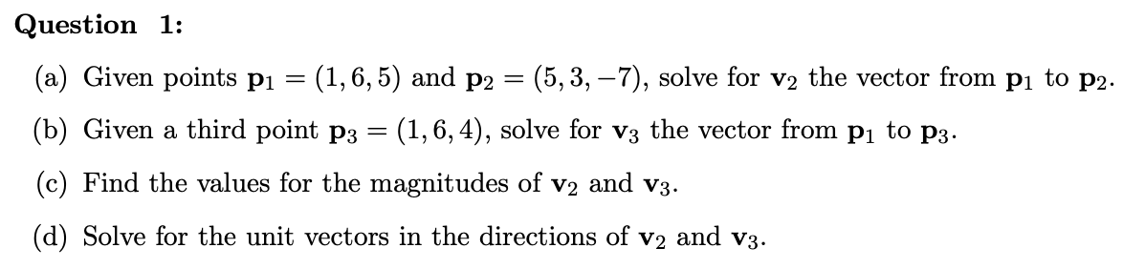

1. My answer is :

The vector v2 from p1 to p2 is p2 - p1 = (5-1, 3-6, -7-5) = (4, -3, -12)

1. My answer is :

The vector v3 from p1 to p3 is p3 - p1 = (1-1, 6-6, 4-5) = (0, 0, -1)

1. My answer is :

Magnitudes of v2 is

Magnitudes of v3 is

1. My answer is :

Unit vector of v2 is v2 / |v2| = (4/13, -3/13, -12/13)

Unit vector of v3 is v3 / |v3| = (0, 0, -1)

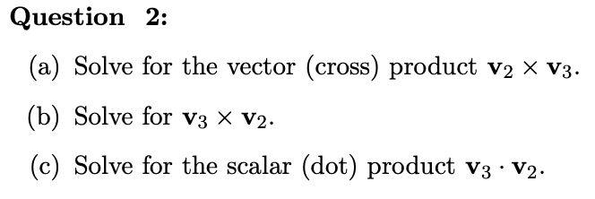

1. My answer is :
$$v_{2}×v_{3}$$

$$=((−3)×(−1)−(−12)×0, (−12)×0−4×(−1), 4×0−(−3)×0)$$

$$=(3, 4, 0)$$

2. My answer is :
$$v_{3}×v_{2}$$

$$=(0×(−12)−(−1) ×(−3), (−1)×4−0×(−12), 0×(−3)−0×4)$$

$$=(−3, −4, 0)$$

3. My answer is :



$$v_{2}∙v_{3}$$

$$=4×0+(−3)×0+(−12)×(−1))$$

$$=12$$

My answer is:

0, since they are orthogonal, which means that the angle between them is 90 degrees and the dot product of the vectors is zero.



My answer is:

(b) and (c) are unit vectors.

For (a):

$$\sqrt[2]{{(1/2)}^{2}+{(−1/2)}^{2}+{(0)}^{2}}=\sqrt[2]{1/2}≠1$$

For (b):

$$\sqrt[2]{{(0)}^{2}+{(−1)}^{2}+{(0)}^{2}}=\sqrt[2]{1}=1$$

For (c):

$$\sqrt[2]{{(−2/7)}^{2}+{(3/7)}^{2}+{(6/7)}^{2}}=\sqrt[2]{1}=1$$

In conclusion, (b) and (c) are unit vectors.

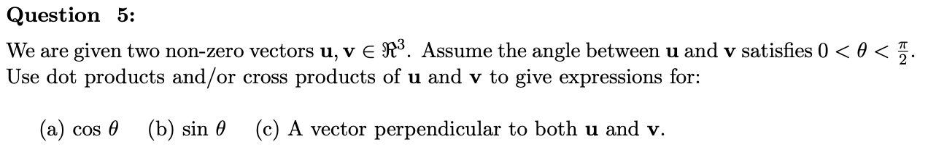

1. My answer is:
$$\cos{θ}=\frac{u∙v}{|u||v|}$$

2. My answer is:
$$\sin{θ}=\frac{|u×v|}{|u||v|}$$

3. My answer is:

$$u×v$$

Since the vector resulting from the cross product u×v is a vector that is perpendicular to both u and v.

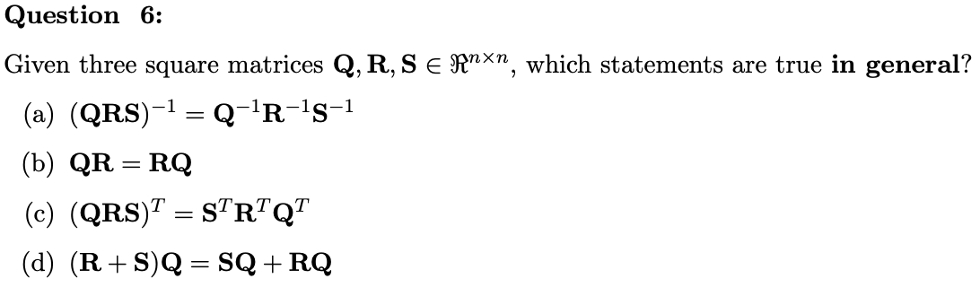

1. My answer is:

It’s false, since ${(QRS)}^{−1}=S^{−1}R^{−1}Q^{−1}$.

1. My answer is:

It’s false, unless they are special matrices.

1. My answer is:

It’s true.

1. My answer is:

It’s true.

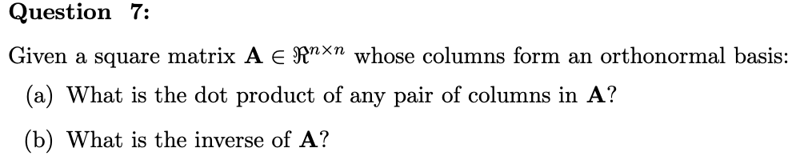

1. My answer is:

It's 1, since A’s columns form an orthonormal basis so that the dot product of each pair of columns in A is 1.

1. My answer is:

Since A’s columns form an orthonormal basis, $A^{−1}=A^{T}$